Lab-Project A1. Splunk: Boss of the SOC
What you need
- A computer with a Web browser.
Purpose
- To learn basics of Splunk usage, with a free online data set and server.
Creating an Account
- In a browser, go to link. Fill in the form on the right side, and click the green Submit button.
- Go through the tour "BOSS OF THE SOC".
- Follow the instructions here and answer the questions below.
Q1. What’s the directory name?
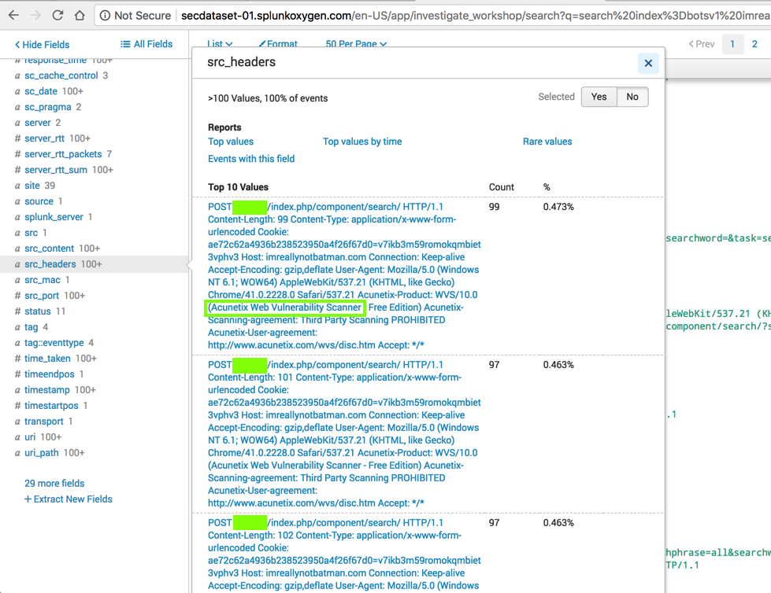
- Make sure the directory greened out in the screenshot above is visible in your screenshot.
- Save the image with the filename Lab-ProjA1-1-YOURNAME.png. Use your real name, not the literal text YOURNAME.
In each of the question from Q2 to Q11: Make sure the answer is clearly visible and save the image with the filename Lab-ProjA1-x-YOURNAME.png with x = 2, 3, …, 11.
Q2. Brute Force Attack
Continue with the "APT Scenario" and find the answer to this question:
What IP address is likely attempting a brute force password attack against imnotreallybatman.com?
Q3. What was the first brute force password used?
Q4. One of the passwords in the brute force attack is James Brodsky's favorite Coldplay song. Which six character song is it?
Q5. What was the Password Used To Gain Access?
Q6. How many unique passwords were attempted in the brute force attempt?
Q7. First Seen Date
Continue with the "APT Scenario" and find the answer to this question:
What is the SHA256 hash of the executable uploaded?
Search VirusTotal.com and find the date that file first was seen in the wild, which is covered by a green box in the image below.
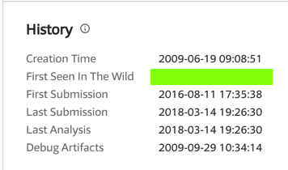
Q8. What is the name of the file that defaced the website?
Q9. Identify the Fully Qualified Domain Name of the System that Defaced the Web Server
Q10. What IP address has P01s0n1vy tied to domains that are pre-staged to attack Wayne Enterprises?
Q11. Identify Associated Malware
Turning in your Project
Submit the images to: cms with a subject line of "Lab-ProjA1 From Your Name", replacing Your Name with your own name.

